BANK DATABASE 2
Query 1: Find all the customers who have an account at all the branches located in a specific city (Ex. Delhi).
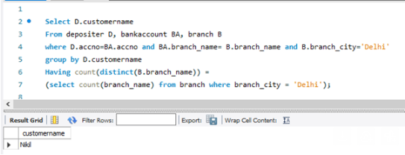

Query 2: Find all customers who have a loan at the bank but do not have an account.
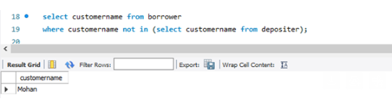

Query 3: Find all customers who have both an account and a loan at the Bangalore branch
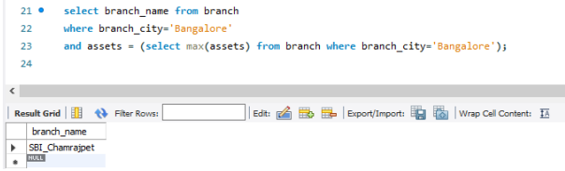
Query 4: Find the names of all branches that have greater assets than all branches located in Bangalore.
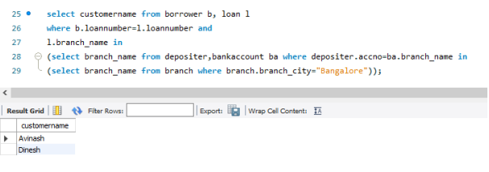

Query 5: Demonstrate how you delete all account tuples at every branch located in a specific city (Ex. Bombay).
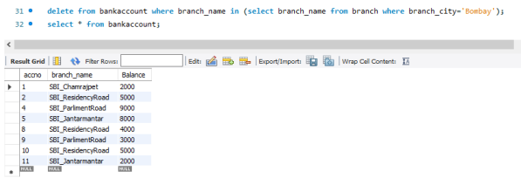
Query 6: Update the Balance of all accounts by 5%

